
Mini Project Report

Dynamic Spatial–Temporal Graph Transformer
for EEG-Based Valence–Arousal Emotion Recognition on the DEAP Dataset
Course: ICE478
Course Title: Machine Learning
Section: 06
Group: 09
Course Instructor: Dr. Raihan Ul Islam

Team Members:
Name | ID
Tahsina Tabassum | 2023-1-50-002
Saima Akter Tisha | 2022-3-50-018
Fariya Ahmed Bhuiyan | 2022-3-50-009
Iftekhar Alam | 2019-2-57-039

Exploratory Data Analysis Report
EEG-Based Emotion Recognition on the DEAP Dataset
Group 9 · Dataset 3 | Source notebook: Group9_Dataset3_EDA.ipynb

1. Introduction and Objective
This report documents the exploratory data analysis (EDA) stage of a project that aims to classify emotional states — valence and arousal — from electroencephalography (EEG) signals, as a precursor to a graph neural network (GNN) model. The notebook works with the DEAP dataset, a widely used benchmark for physiological emotion recognition, and covers data acquisition, structural verification, label distribution analysis, raw-signal inspection, frequency-band feature extraction, subject-aware train/test splitting, and construction of an electrode-adjacency graph that will feed the downstream GNN. This document summarizes each stage, the checks performed, and the observations that inform later modeling choices.

2. Dataset Overview
The DEAP (Database for Emotion Analysis using Physiological Signals) dataset was retrieved via kagglehub ("manh123df/deap-dataset"). It contains preprocessed EEG recordings for 32 participants, each of whom watched 40 one-minute music video excerpts while their EEG and peripheral physiological signals were recorded. After each trial, participants self-reported valence, arousal, dominance, and liking on a continuous 1–9 scale.
Subjects: 32 (one .dat file per subject, e.g. s01.dat … s32.dat)
Trials per subject: 40 (verified identical across all 32 subjects)
EEG channels used: 32 (10-20 system montage)
Sampling rate: 128 Hz
Trial length: 8064 samples (63 s), including a 3 s pre-stimulus baseline
Labels: valence, arousal, dominance, liking — continuous, range approx. 0–9
Auxiliary metadata (participant questionnaires, video/stimulus lists, and self-report ratings in .xls/.xlsx form) and MIDI stimulus files are also bundled with the dataset but are not used in this EDA.

3. Data Loading and Integrity Checks
Each subject file is a Python pickle containing a dictionary with two arrays: "data" (trials × channels × samples) and "labels" (trials × 4 rating dimensions). The notebook performs the following sanity checks before any feature work:
- Shape verification: the first subject's data array has shape (40, 40, 8064) — 40 trials, 40 recorded channels (EEG + peripheral, of which the first 32 are EEG), 8064 time samples — and the labels array has shape (40, 4).
- Missing-value check: no NaNs found in either the EEG data or the labels for the inspected subject.
- Label range check: observed label minimums/maximums (valence 0–8.27, arousal 1–8.15, dominance 2.04–9, liking 3.87–8.47) are consistent with the documented 1–9 self-report scale.
- Cross-subject consistency: looping over all 32 subject files confirms every subject contributes exactly 40 trials, so the dataset is structurally uniform before any records are dropped.
These checks establish that the raw data is complete and structurally consistent, which justifies treating all 32 subjects identically in the feature-extraction stage.

4. Label Distribution Analysis
To understand class balance for the classification task, valence and arousal ratings were pooled across all 32 subjects (1,280 trials total) and visualized as histograms, alongside the class counts that result from binarizing each dimension at the conventional threshold of 5.
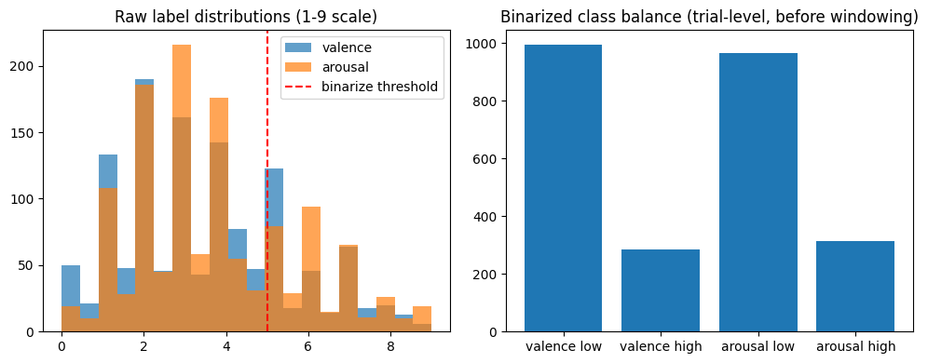
Figure 1. Left: raw valence and arousal rating distributions (1–9 scale) with the binarization threshold marked. Right: resulting binary class counts at the trial level.
Both raw distributions are unimodal and skew toward the upper-middle of the scale, which is typical for self-reported affect data. After binarizing at the midpoint (rating ≥ 5 → "high"), both target dimensions show a pronounced class imbalance:
Dimension | Low class (trials) | High class (trials) | High-class share
Valence | 995 | 285 | ≈22%
Arousal | 965 | 315 | ≈25%
This imbalance is an important consideration for the downstream model: naive accuracy would be a misleading metric, and class weighting, balanced sampling, or threshold tuning should be considered when training a classifier on the binarized labels.

5. Raw Signal Inspection
A single representative trial (Subject 1, Trial 1, channel Fp1) was plotted in the time domain to check that the preprocessed EEG looks physiologically plausible and to locate the baseline segment.
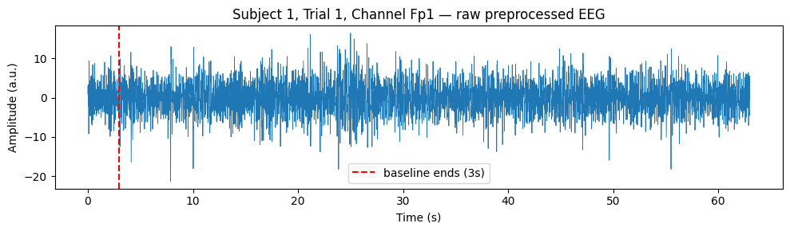
Figure 2. Raw preprocessed EEG for one channel/trial, with the 3-second baseline boundary marked.
The signal oscillates around zero with no obvious drift, clipping, or flat segments, consistent with data that has already been band-pass filtered and re-referenced by the dataset providers. Summary statistics for this channel/trial (mean ≈ -0.03, std ≈ 3.89, range approximately [-21.3, 16.5]) confirm the signal is zero-centered with amplitude in a reasonable arbitrary-unit range, supporting the decision to apply per-trial, per-channel z-score normalization during feature extraction rather than additional filtering.

6. Frequency-Band Feature Extraction
Raw EEG is high-dimensional and noisy for direct modeling, so the notebook derives band-power features, a standard representation for EEG-based affect recognition. For each trial, the 3-second baseline is discarded, each channel is z-scored, and the remaining signal is split into non-overlapping 4-second windows. Within each window, Welch's method estimates the power spectral density per channel, which is numerically integrated (trapezoidal rule) over five canonical EEG bands:
Band | Frequency range (Hz)
Theta | 4 – 8
Alpha | 8 – 13
Low beta | 13 – 20
High beta | 20 – 30
Gamma | 30 – 45
A log1p transform is applied to compress the dynamic range of the resulting band-power values. Feature extraction is parallelized across CPU cores and cached to disk (deap_eeg_features.npz) to avoid recomputation. Due to the computational cost of this step, only the first 19 of the 32 subjects (MAX_SUBJECTS = 19) were processed for this stage.
Resulting feature tensor: (11,400 windows × 32 channels × 5 bands)
Valence balance (windows): 8,850 low / 2,550 high (≈22% high)
Arousal balance (windows): 8,625 low / 2,775 high (≈24% high)
Subjects represented: 19
The class imbalance observed at the trial level (Section 4) persists at the window level, as expected, since windowing a trial does not change its label.

7. Train/Test Split Strategy
A naive random split over windows would leak subject-specific signal characteristics between training and test sets, since each subject contributes many correlated windows. To prevent this, a GroupShuffleSplit (80/20) is used with subject ID as the grouping key, guaranteeing that no subject appears in both sets. This was verified explicitly with a disjointness assertion on the subject sets.
Training set: 9,000 windows from 15 subjects
Test set: 2,400 windows from 4 subjects
Feature standardization (mean/std) is fit only on the training split and then applied to both splits, avoiding test-set information leakage into the normalization statistics.

8. Electrode Graph Construction
Because the intended downstream model is a graph neural network, the EDA also builds the graph structure that will represent spatial relationships between the 32 EEG electrodes. Each electrode is assigned an approximate 2D scalp coordinate (a simplified 10-20 montage layout). Pairwise Euclidean distances between electrodes are converted into similarity weights via a Gaussian kernel, and each node is connected to its 5 nearest neighbors (k = 5) by weight, producing a sparse, spatially-informed adjacency structure.
Nodes: 32 (one per EEG channel)
Edges: 160 directed edges (k = 5 nearest neighbors per node)
This graph (edge_index, edge_weight) is reused for every trial/window, on the assumption that spatial electrode relationships are stable across trials and subjects.

9. Bridge to Modeling
The final cells move from analysis into model-input preparation rather than pure EDA: features and labels are wrapped in a PyTorch Geometric Dataset (EEGGraphDataset) that pairs each window's 32×5 feature matrix with the shared electrode graph, and DataLoaders are created for training (batch size 32, shuffled) and testing (batch size 64, unshuffled). This confirms the EDA output is in the correct shape and format to be consumed directly by a GNN, but no model is trained or evaluated in this notebook.

10. Summary of Key Findings
- The dataset is structurally complete and consistent: 32 subjects × 40 trials, no missing values, labels within the expected 1–9 range.
- Both valence and arousal are imbalanced after binarization, with the "high" class making up roughly one-fifth to one-quarter of samples — a factor that should inform the choice of loss function or evaluation metric.
- Raw EEG amplitude and noise characteristics look physiologically reasonable, supporting per-channel z-score normalization as the chosen preprocessing step.
- Band-power features (theta through gamma, 4-second windows) reduce each trial to a compact, interpretable representation while preserving per-channel spatial resolution.
- Subject-grouped splitting is used throughout to prevent subject leakage between train and test data, which is essential for a realistic estimate of cross-subject generalization.
- A k-nearest-neighbor electrode graph (k = 5) built from 2D scalp coordinates is prepared as the spatial structure for the intended GNN model.

11. Limitations and Next Steps
- Only 19 of 32 subjects were used for feature extraction (MAX_SUBJECTS = 19); extending to the full cohort would improve statistical power and subject diversity in both splits.
- Only valence is carried through to the graph dataset construction in this notebook; an equivalent arousal pipeline would need to be built for that target.
- The electrode graph uses an approximate, hand-placed 2D coordinate layout rather than true 10-20 system coordinates or a data-driven (e.g., correlation-based) adjacency, which could affect how well the graph reflects real spatial/functional relationships.
- No outlier or artifact-rejection analysis (e.g., eye-blink or muscle-artifact detection) is shown; the dataset's pre-processing is assumed to have handled this.
- Class imbalance is identified but not yet addressed (e.g., via class weighting or resampling) — this should be handled explicitly at the modeling stage.

